# Ex no: 6 210701015

Import a JSON file from the command line and apply actions with the data present in the JSON file

# Aim:

To import a JSON file from the command line and apply the following actions with the

data present in the JSON file where, projection, aggregation, remove, count, limit, skip and sort.

# Procedure:

**Hive Download and installation:**

1. Starting Hadoop Services

Open PowerShell as administrator and go to Hadoop sbin directory and start hadoop services using the following commands: Start-all.cmd



1. Create a .json file with the below content:

{"id": 1, "name": "John Doe", "age": 30, "salary": 50000}

{"id": 2, "name": "Jane Smith", "age": 25, "salary": 60000}

{"id": 3, "name": "Alice Johnson", "age": 28, "salary": 55000}

{"id": 4, "name": "Bob Brown", "age": 35, "salary": 70000}

{"id": 5, "name": "Charlie Davis", "age": 40, "salary": 80000}

{"id": 6, "name": "Eve White", "age": 22, "salary": 48000}

{"id": 7, "name": "Frank Black", "age": 32, "salary": 65000}

{"id": 8, "name": "Grace Green", "age": 27, "salary": 52000}

{"id": 9, "name": "Henry Gold", "age": 29, "salary": 59000}

{"id": 10, "name": "Isabel Blue", "age": 33, "salary": 73000} Derby Network Server:

Run the following command to open Derby: StartNetworkServer -h 0.0.0.0

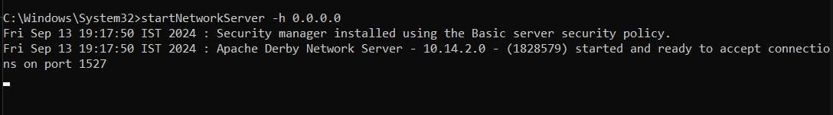

Go to first PowerShell window and check whether NetworkServerControl is running.

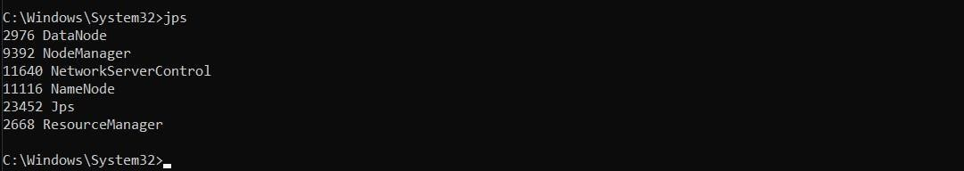

1. Starting Apache Hive:

Go to Apache Hive’s bin location with cd command and run the following command: hive --service schematool -dbType derby –initSchema

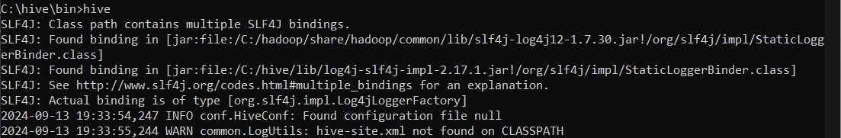8. Open Hive shell by typing: hive

# Create a Database:

Start by creating a database. Open the Hive CLI and follow the steps below:

1. Use the **CREATE DATABASE** statement to create a new database: CREATE DATABASE IF NOT EXISTS emp_json;
2. Verify the database is present:

SHOW DATABASES;

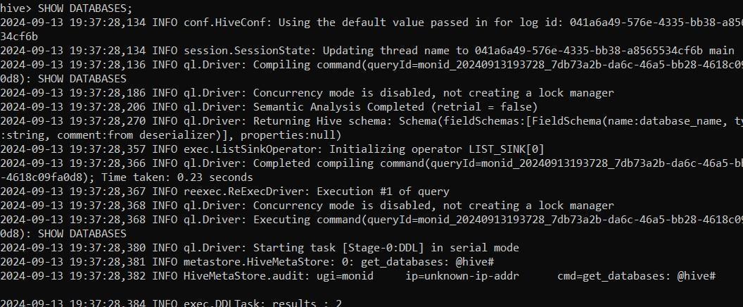

# Create a Table in Hive:

CREATE TABLE employees_table ( id INT,

name STRING, age INT, salary DOUBLE

)

ROW FORMAT SERDE 'org.apache.hive.hcatalog.data.JsonSerDe' STORED AS TEXTFILE

LOCATION '/ser/hive/warehouse/emp_json/';

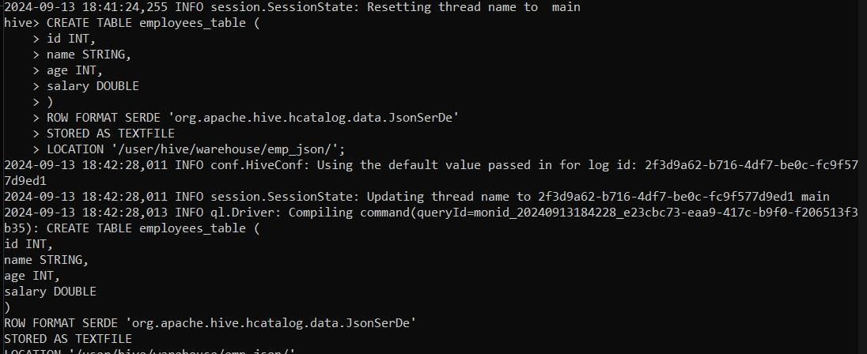

# Add Data to the TABLE:

Run the **LOAD DATA INPATH** command:

LOAD DATA INPATH '/user/hive/warehouse/emp_json/employee.json' INTO TABLE employees_table;

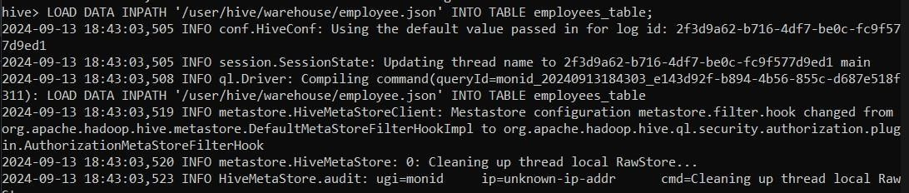

# List Hive Tables and Data:

To show all tables in a selected database, use the following statement:

SHOW TABLES;

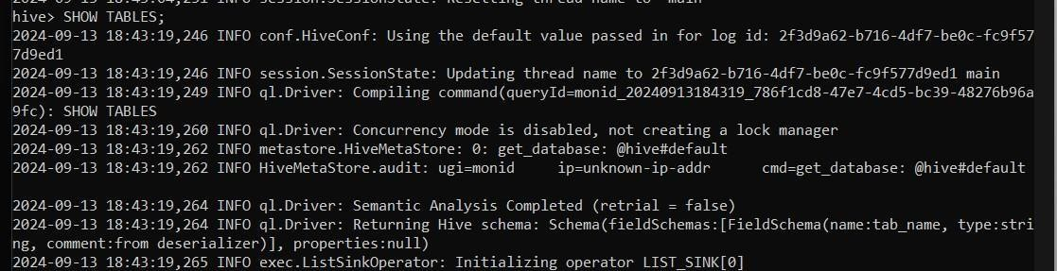

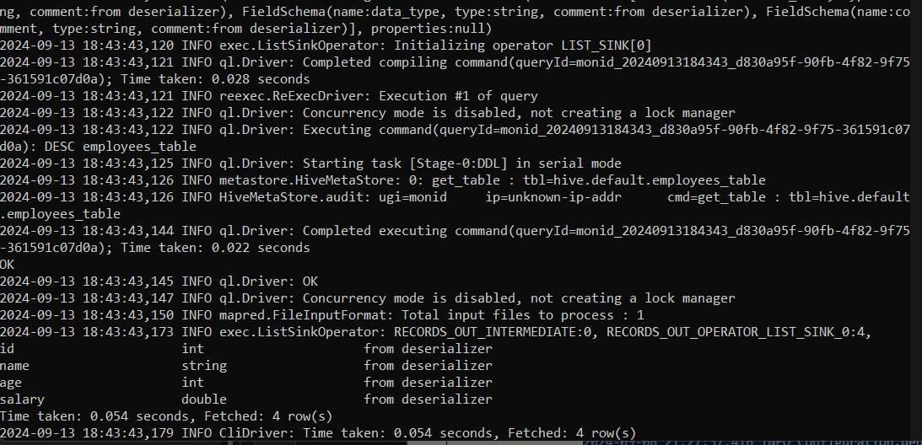To show table column names and data types, run: DESC employees_table;

To display table data, use a **SELECT** statement. For example, to select everything in a table, run:

SELECT * FROM employees_table;

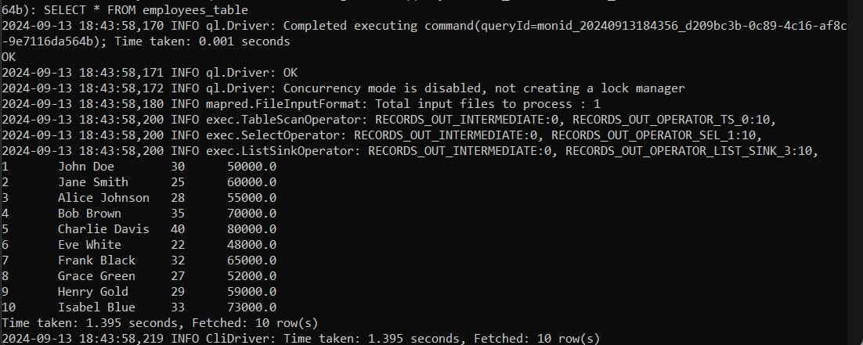

**Perform Various Operations on the Data in the table: WHERE:**

SELECT id, name, age, salary FROM employees_table WHERE salary > 60000;

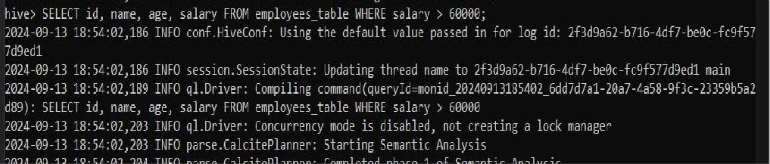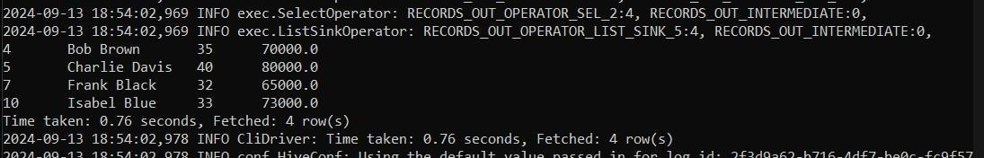

# PROJECTION: (Selecting Specific Columns)

SELECT id, name FROM employees_table;

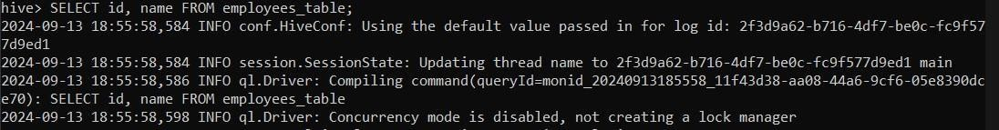

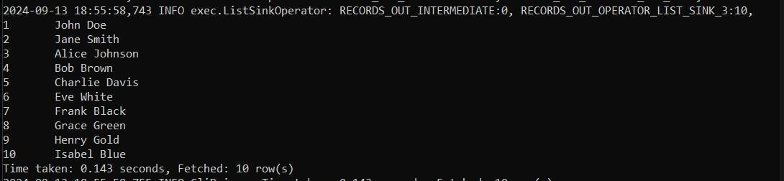

# AGGREGATION: (e.g., Summing Salaries by Age Group)

SELECT age, MAX(salary) AS max_salary FROM employees_table GROUP BY age;

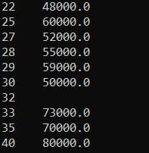

# REMOVE: (Remove Specific Records)

SELECT * FROM employees_table WHERE salary > 70000;



# COUNT: (Counting the Number of Records)

SELECT COUNT(*) FROM employees_table;



# LIMIT: (Restrict the Number of Rows Returned)

SELECT * FROM employees_table LIMIT 5;

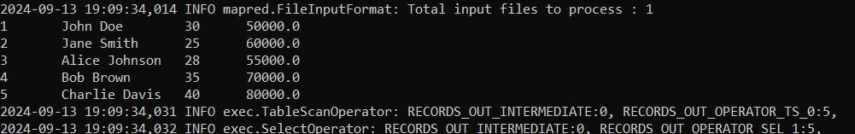

# SKIP: (Skipping the First N Rows, using Row Number)

SELECT * FROM ( SELECT *, ROW_NUMBER() OVER () AS row_num FROM

employees_table ) temp WHERE row_num > 3;



# SORT: (Order the Data by Salary)

SELECT * FROM employees_table ORDER BY salary DESC;



# Result:

Thus, to import a JSON file from the command line and apply the following actions with the data present in the JSON file where, projection, aggregation, remove, count, limit, skip and sort was completed successfully.